Figure 1: First Level in the game, Player spawns in the room map showing player and current position.

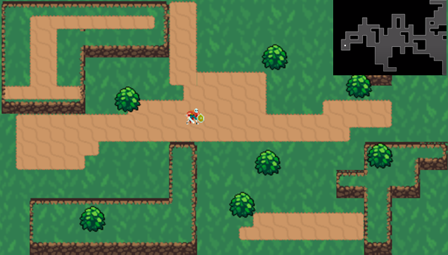

Figure 2: Player enters normal room; enemies spawn that players must kill 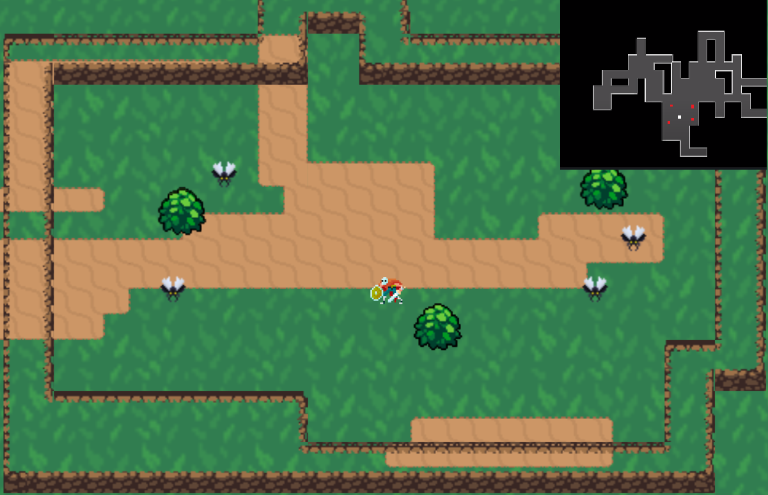

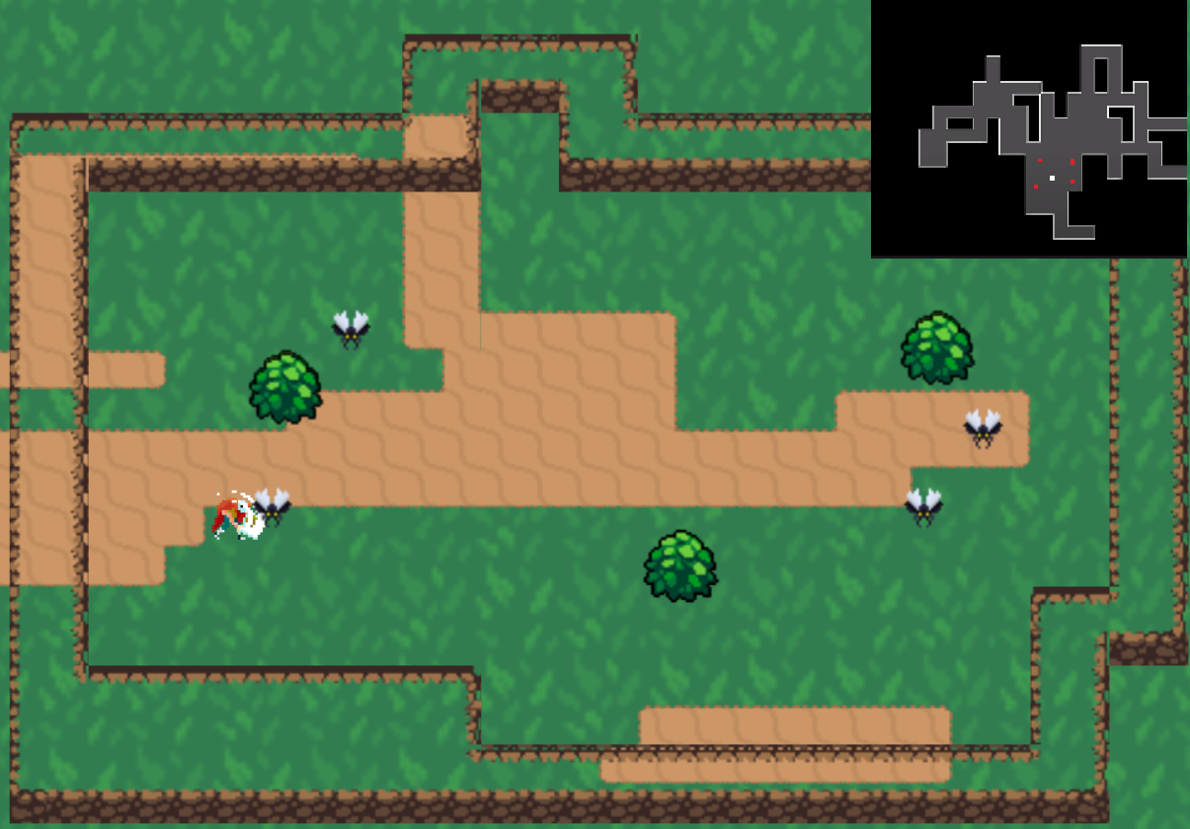Figure 3: Player attacking enemy .

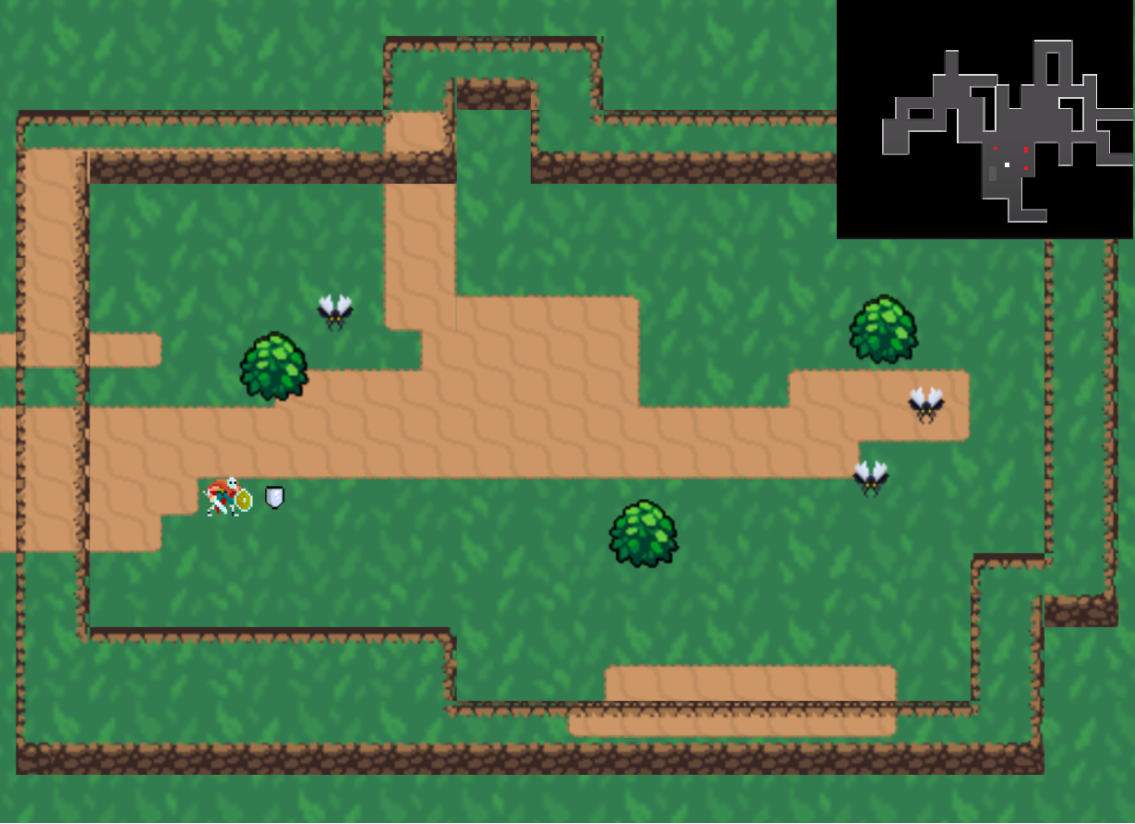Figure 4: Enemy Dropping item.

Figure 5: Player enters boss room, One boss spawns

